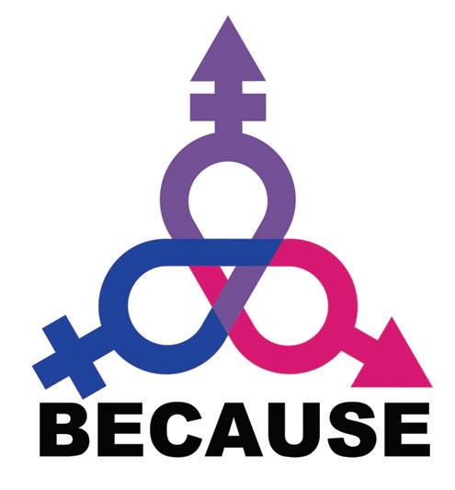

BECAUSE 2017 Conference
Coming Home: A Bi+ Past, Present, & Future

The Bisexual Organizing Project is pleased to announce BECAUSE will be returning this fall for its 25th year anniversary. This year’s conference is titled Coming Home: A Bi+ Past, Present, & Future. The conference will take place on November 10th-12th, 2017 at Metropolitan State University in Saint Paul, Minnesota.

BECAUSE seeks to build an empowered bisexual, pansexual, fluid, queer, and unlabeled (bi+) community in the United States. BECAUSE, which stands for "Bisexual Empowerment Conference; A Uniting Supportive Experience," is welcoming and inclusive of all people, including but not limited to people of all ages, genders, gender identities, sexual orientations, sexes, relationship orientations, races, ethnicities, national origins, abilities, religions, sizes, political affiliations, and other identities. BECAUSE is the largest conference for bi+ individuals in the United States. Every year, people travel from across the nation and even from other countries to attend this event.

According to the Movement Advancement Project’s 2015 study, “Invisible Majority: The Disparities Facing Bisexual People and How to Remedy Them”, 52% of the LGBTQ population identifies as bisexual. Despite this fact, the San Francisco Human Rights Commission’s 2011 “Bisexual Invisibility Report” found that only 3-20% of people accessing LGBTQ resources are bisexual. Furthermore, the report revealed that in 2008, while total foundation giving to LGBTQ issues increased from $77 million in 2007 to $107 million in 2008, funding for bi+ organizations or programs went down; it was the lowest of all two dozen demographic groups tracked. In fact, not a single grant in the entire country explicitly addressed bisexual issues. These statistics illuminate the bisexual community’s critical need for institutional support, and why it is vital for BECAUSE to continue to stand as a cornerstone of bi+ activism, as it has for the last quarter of a century.

We are seeking sponsorship to make this conference accessible to all members of our community. A 2013 survey of LGBTQ Americans conducted by The Pew Research Center found that 48% of bisexual respondents reported an annual family income of less than $30,000. Due to this income disparity between bisexuals and their peers in the LGBTQ community, we find that a significant number of our conference attendees each year require financial assistance to attend BECAUSE. We believe offering scholarships wherein attendees must demonstrate financial need creates more barriers to attendance, rather than eliminating them. Instead, we choose to implement a pay-what-you-can system, in which no one is turned away for lack of funds. This means it is vital that we secure funding to pay for the conference without relying on registration fees. In light of these circumstances, we would like to extend an opportunity to your organization to provide this invaluable financial support through conference sponsorship.
Thank you so much for your support of this conference. Making space for bi+ people to gather and be around others like themselves is vital and lifesaving, especially in today’s political climate. We hope that investing in a bi+ past, present, and future today, will keep this conference going for another 25 years. Thank you.
Sincerely,
BECAUSE 2017 Co-Chairs, AL & Sally *see reverse*
To Donate:
Questions? Contact us at BECAUSE@bisexualorganizingproject.org

Credit card:
- Click HERE to access our Eventbrite site. (Scroll down to the option “Donation to support BECAUSE”)
- The treasurer will contact you regarding your benefits package within 1-10 days.

Check:
- Please make checks payable to the Bisexual Organizing Project (put “BECAUSE” in the Memo Line)
- Send checks to: Bisexual Organizing Project, c/o: Outfront MN, 310 East 38th Street, Suite 209, Minneapolis, MN 55409

Sponsorship Benefits Package: BECAUSE 2017

 | Presenting  Sponsor  $10,000+ | Diamond  Level  $5,000+ | Titanium  Level  $2,500+ | Platinum  Level  $1,000+ | Gold  Level  $500+ | Silver  Level  $250+ | Bronze  Level  $100+ | Individual  Donor  $40+
 | Advertising Features
Name Recognition in program booklet
Logo recognition in program booklet
Ad space in program booklet | Full page COLOR | Full page | Full page | ½ page | ¼ page | Mini ad
Printed materials (of choice) added to conference swag bags
Live link on conference website & social media blasts
 | Venue & Conference Features
Complementary table during Resource Fair
Verbal recognition on stage
Stage time for welcoming remarks
Video Loop of org’s promo video(s)
Organization listed as “Presenting Sponsor” on website, printouts, and social media

